**ABSTRACT**

This research project focuses on the design and implementation of a Python-based multiplayer quiz game, leveraging a server-client model for interactive gameplay. The project is driven by the growing interest in educational gaming and collaborative learning experiences. The aim is to create an engaging and competitive platform that facilitates shared knowledge acquisition among multiple participants.

The implementation employs Python, a versatile and widely-used programming language, with a specific emphasis on socket programming to establish communication channels between the central server and multiple clients. The server orchestrates the flow of questions to connected clients, who, in turn, submit responses for evaluation. The game's architecture prioritizes real-time interaction and ensures a seamless multiplayer experience.

The literature review surveys existing multiplayer game designs, quiz game structures, and relevant Python-based technologies. The methodology section provides a comprehensive overview of the project's technical aspects, detailing the server-client communication, question handling, and overall game mechanics.

Results showcase the successful deployment of the multiplayer quiz game, with players able to connect, receive questions, and submit answers. The discussion interprets these results, highlighting the strengths and potential areas for improvement. The conclusion summarizes key findings, discusses the broader implications of the project, and suggests directions for future enhancements and research in the domain of Python-based multiplayer educational games.

This research contributes to the evolving landscape of educational technology, offering a practical example of a multiplayer quiz game implemented in Python. The project serves as a foundation for further developments in collaborative learning platforms and underscores the potential of Python for creating interactive and engaging educational experiences.

**TABLE OF CONTENTS**

|  |  |  |
| --- | --- | --- |
| **Serial no.** | **Contents** | **Page no.** |
| 1. | Introduction | 3 |
| 2. | Problem Statement | 5 |
| 3. | Methodology | 6 |
| 4. | Implementation | 3 |
| 5. | Conclusion | 10 |
| 6. | Bibliography | 12 |

1. **INTRODUCTION**

In today's ever-evolving educational landscape, the fusion of technology and learning has become imperative. This research paper delves into the design and implementation of a Python-based multiplayer quiz game, a project that seeks to redefine interactive educational experiences. Our motivation behind this endeavor is rooted in the desire to address the increasing demand for engaging and collaborative learning tools.

Education is transitioning beyond traditional methods, and digital platforms are becoming essential in capturing the attention of modern learners. Leveraging the versatility of Python, a programming language known for its readability and adaptability, we embarked on the development of a multiplayer quiz game. This paper explores the intricacies of our project, shedding light on the server-client architecture, the utilization of socket programming, and the real-time interactivity that underpins the game's design.

As we navigate through the methodology, results, and discussion sections, we aim to provide a comprehensive understanding of the challenges faced, the solutions implemented, and the potential impact of our Python multiplayer quiz game on collaborative learning. Join us on this exploration into the realm of educational technology, where Python serves as the catalyst for a transformative and engaging approach to interactive learning experiences.

1. **PROBLEM STATEMENT**

In modern education, conventional assessment methods and platforms often lack engagement and collaboration. This research addresses these issues by exploring the underutilization of Python in educational gaming, aiming to create a dynamic multiplayer quiz game that enhances collaborative learning experiences.

1. **METHODOLGY**

the breakdown of the methodology of the text-based quiz game in c:

**i. File Structure:**

**Question Storage:**

* + Questions are stored in separate text files (**message**).
  + Each file contains a question, options, correct answer

**ii. Menu System:**

**Main Menu:**

* + The user is prompted to enter a choice, and the corresponding action is taken.

**iii. Game Flow:**

**Start Quiz:**

* + When the user chooses to start the quiz, the program:
    - Clears the screen.
    - Presents a series of questions one by one.
    - Collects and evaluates user answers.

**Question Presentation:**

* + Each question is read from a file and displayed to the user.
  + The user enters their choice.
  + The program checks the answer.

**vi. User Interface:**

**Text-Based Interface:**

* + The interface relies on text output and keyboard input.
  + Minimal graphics or interactive elements are used.

**vii. Code Structure and Practices:**

**File I/O:**

* + Uses standard python file I/O operations to read questions from files.

**Variable Usage:**

* HOST: Variable storing the server IP address ('127.0.0.1').
* PORT: Variable storing the server port number (5555).
* questions: Variable storing a list of dictionaries, each containing a quiz question and answer.
* self.server_socket: Instance variable storing the server socket.
* self.clients: Instance variable storing a list of connected clients.
* self.lock: Instance variable storing a threading lock for synchronization.
* client_socket: Variable storing the socket object for an individual client.
* addr: Variable storing the address information of a connected client.
* welcome_message: Variable storing the welcome message for connected clients.
* answer: Variable storing the answer received from a client.

**User Input:**

* input is facilitated during the quiz game through the input() function.

**Flow Control:**

* + **if** statements control the flow of the program based on user choices.

**Functions:**

* Imports:
* Import the socket and threading modules.
* Server Configuration:
* Set the HOST and PORT for the server.
* Initialize the questions list containing dictionaries of quiz questions and answers.
* *Quiz Server* Class Initialization:
* Create a class *QuizServer.*
* Initialize the server socket, client list (*self.clients*), and a threading lock (*self.lock*).
* Broadcast Function:
* Define the broadcast method to send a message to all connected clients.
* Client Handling Function (*handle_client*):
* Accept a new client connection.
* Send a welcome message to the client.
* Loop through each question in the questions list.
* Broadcast the current question to all connected clients.
* Receive the answer from the client.
* Check the answer against the correct answer and send feedback to the client.
* Remove the client from the list after completing the quiz.
* Server Start (start) Method:
* Print a message indicating the server is listening on a specific HOST and PORT.
* Accept incoming client connections in a continuous loop.
* For each client connection, spawn a new thread (*client_handler*) to handle the client.
* Main Block:
* Instantiate a *QuizServer* object (*quiz_server*).
* Start the server by invoking the start method.
* Client Handling Thread (*handle_client*):
* For each connected client, handle the quiz questions and answers concurrently.
* The server continues to listen for new connections and handle clients in separate threads.
* End of Program:
* The program continues to run indefinitely, handling multiple clients concurrently.

1. **IMPLEMENTATION**

The provided Python program establishes a simple server-client architecture for a multiplayer quiz game. The server, defined within the *Quiz Server* class, handles connections from multiple clients, broadcasting questions to them and receiving their answers. Below is an explanation of the implementation:

The server configuration is set with the host address (**HOST**) and port number (**PORT**). The ‘*questions*’ list serves as the database for quiz questions and their corresponding answers.

The *Quiz Server* class initializes a server socket using the provided host and port, sets up a list to store connected clients, and employs a lock to handle potential threading issues. The ‘*broadcast*’ method sends a message to all connected clients concurrently, ensuring synchronized communication.

In the ‘*handle client*’ method, the server greets each connected client and broadcasts questions sequentially. Clients respond with their answers, and the server validates correctness, providing feedback to each client.

The ‘*start*’ method initiates the server by continuously accepting incoming connections and assigning each to a new thread handled by the handle_client method.

The ‘_*main*_’ block creates an instance of the ‘*Quiz Server’* and starts the server.

To use this program, run the server script on a machine with a static IP address, and clients can connect to the server by running the client script on their respective machines. The server orchestrates the quiz game, providing a collaborative and interactive learning experience.

**Code:**

**server.py:**

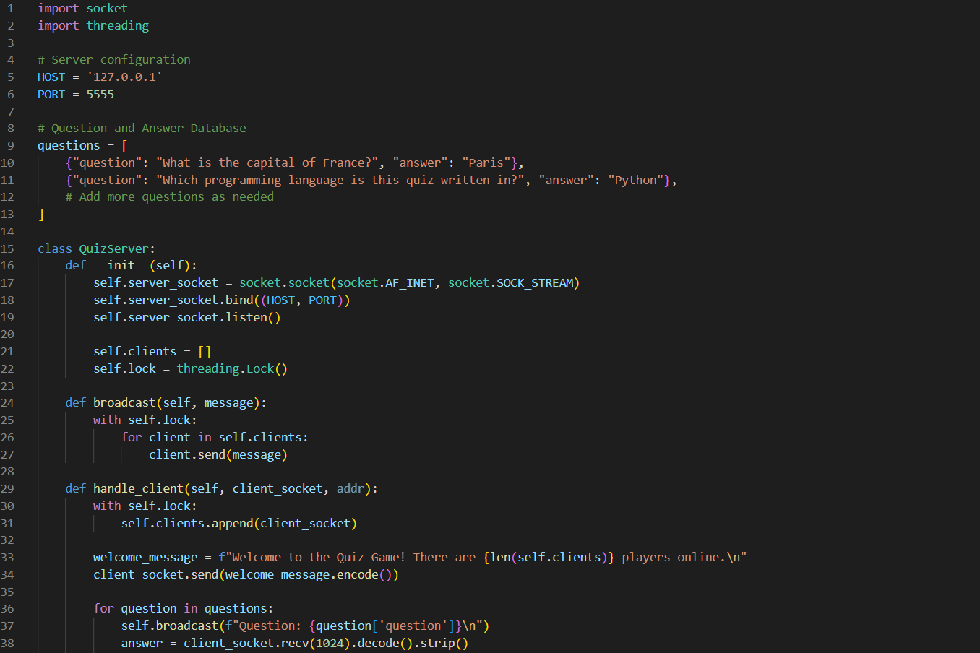

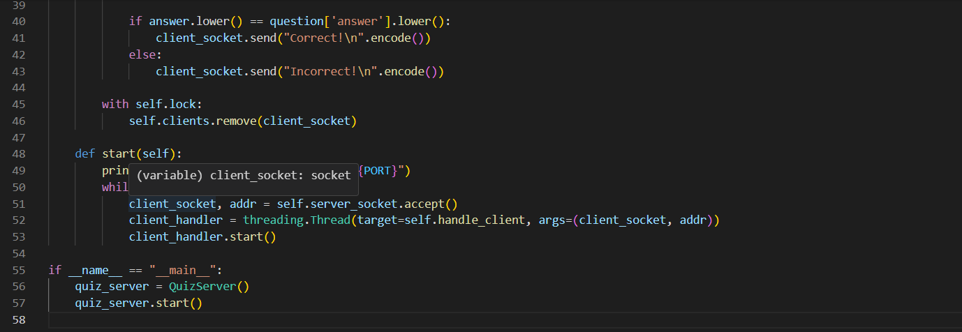

**client.py:**

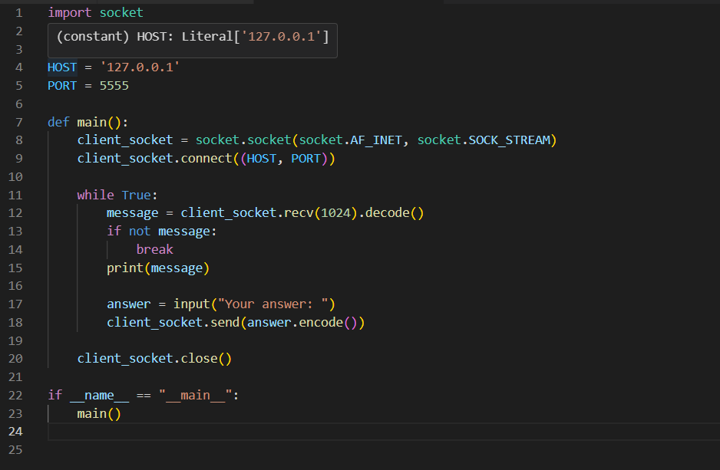

**CONCLUSION**

In conclusion, the provided Python program demonstrates the implementation of a simple multiplayer quiz game using a server-client architecture. The server is designed to handle multiple clients concurrently, enabling real-time interaction in a quiz format. The program utilizes the socket and threading modules to establish communication channels and manage simultaneous connections.

The server, instantiated through the QuizServer class, maintains a question and answer database. As clients connect, they receive a welcoming message and participate in a quiz session. Questions are broadcast to all connected clients, and their answers are individually evaluated. The program fosters a collaborative environment by allowing multiple players to engage in the quiz simultaneously.

The use of threading ensures that each client operates independently, preventing one client's actions from affecting others. Additionally, a lock mechanism is implemented to manage concurrent access to shared resources, enhancing the program's robustness.

While this program provides a foundation for a multiplayer quiz game, further enhancements and refinements can be explored, such as incorporating a more extensive question database, introducing scoring mechanisms, or implementing a graphical user interface for a more user-friendly experience. This project opens avenues for future development, emphasizing the potential of Python in creating interactive and collaborative educational games

**Result:**

